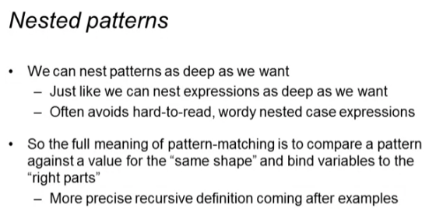

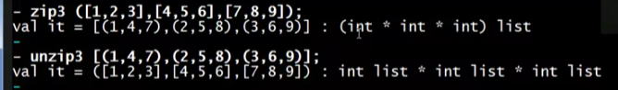

Using old features:

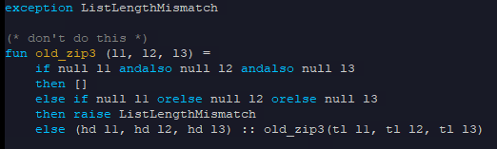

Using pattern matching of what we’ve learned so far:

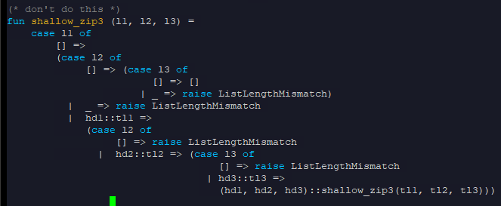

Using nested pattern matching

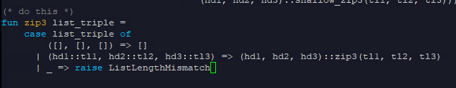

* “_” underscore matches everything and doesn’t bind any variables (like else)

